**Chatbot for Mining Industry**

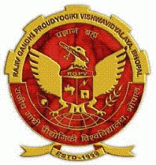A Minor Project Report Submitted To

Rajiv Gandhi Proudyogiki Vishwavidyalaya, Bhopal

Towards Partial Fulfilment for the Award Of

Bachelor of Technology

In

**ARTIFICIAL INTELLIGENCE & DATA SCIENCE**

Submitted By

**Ayush Bhagwat (0863AD211016)**

**Chetan Khapedia (0863AD201011)**

**Nakshatra Bhadore (0863AD211038)**

**Aman Gangwani (0863AD211006)**



Under the Supervision of

**Prof./Dr./Asst. Prof. Atul Barve**

Session: 2023-2024

**Department of Artificial Intelligence & Data science**,

**Prestige Institute of Engineering, Management and Research, Indore (M.P.)**

[An Institution Approved By AICTE, New Delhi & Affiliated To RGPV, Bhopal]

**PRESTIGE INSTITUTE OF ENGINEERING MANAGEMENTAND RESEARCH**

**INDORE (M.P.)**

**DECLARATION**

We **Ayush Bhagwat, Chetan Khapedia, Nakshatra Bhadore, and Aman Gangwani** hereby declare that the project entitled “**CHATBOT FOR MINING INDUSDRY**”, which is submitted by us for the partial fulfilment of the requirement for the award of Bachelor of Technology in Artificial Intelligence & Data Science to the Prestige Institute of Engineering, Management and Research, Indore (M.P.)*.* Rajiv Gandhi Proudhyogiki Vishwavidyalaya, Bhopal, comprises my own work and due acknowledgement has been made in text to all other material used**.**

Signature of Students:

Date:

Place:

**PRESTIGE INSTITUTE OF ENGINEERING MANAGEMENTAND RESEARCH**

**INDORE (M.P.)**

**DISSERTATION APPROVAL SHEET**

This is to certify that the dissertation entitled **“CHATBOT FOR MINING INDUSDRY”** submitted by **Ayush Bhagwat (0863AD211016), Chetan Khapedia (0863AD201011), Nakshatra Bhadore (0863AD211038), and Aman Gangwani (0863AD211006)** to the Prestige Institute of Engineering, Management and Research, Indore (M.P.) is approved as fulfilment for the award of the degree of Bachelor of Technology in Artificial Intelligence & Data Science by Rajiv Gandhi Proudhyogiki Vishwavidyalaya, Bhopal, (M.P.).

**Internal Examiner External Examiner**

Date: Date:

**HOD, AI & DS**

**Dr. Dipti Chauhan**

**PIEMR, INDORE**

**PRESTIGE INSTITUTE OF ENGINEERING MANAGEMENTAND RESEARCH**

**INDORE (M.P.)**

**CERTIFICATE**

This is certified that project entitled “**CHATBOT FOR MINING INDUSDRY**” submitted by **Ayush Bhagwat, Chetan Khapedia, Nakshatra Bhadore and Aman Gangwani** is a satisfactory account of the bona fide work done under our supervision and is recommended towards partial fulfilment for the award of the degree Bachelor of Technology in Artificial Intelligence & Data Science to Rajiv Gandhi Proudyogiki Vishwavidyalaya, Bhopal (M.P.) .

**Date:**

**Enclosed by:**

Prof. Atul Barve Prof. Atul Barve Dr. Dipti Chauhan

**Project Guide Project Coordinator Professor & Head, AI & DS**

**Dr. Manojkumar Deshpande**

**Director**

**PIEMR, Indore**

**PRESTIGE INSTITUTE OF ENGINEERING MANAGEMENTAND RESEARCH**

**INDORE (M.P.)**

**ACKNOWLEDGEMENT**

After the completion of Minor project work, words are not enough to express my feelings about all these who helped me to reach my goal; feeling above this is my indebtedness to the almighty for providing me this moment in life.

First and foremost, we take this opportunity to express my deep regards and heartfelt gratitude to my project guide **Prof./Dr./Asst. Prof. Atul Barve and Project Coordinator Name of Coordinator, Department of Artificial Intelligence & Data Science, PIEMR, Indore** for their inspiring guidance and timely suggestions in carrying out my project successfully. They are also the constant source of inspiration for me. Working under their guidance has been an opportunity for me to learn more and more.

We are extremely thankful to **Dr. Dipti Chauhan, (HOD, AI & DS)** for her co-operation and motivation during the project. I extend my deepest gratitude to **Dr. Manojkumar Deshpande, Director, PIEMR, and Indore** for providing all the necessary facilities and true encouraging environment to bring out the best of my endeavour’s.

We like to thank all the teachers of our department for providing invaluable support and motivation. I remain indebted to all the non-teaching staff of our Institute who has helped me immensely throughout the project.

We are also grateful to my friends and colleagues for their help and co-operation throughout this work. Last but not least; we thank my family for their support, patience, blessings and understanding while completing my project.

**Name of Students:**

**Ayush Bhagwat (0863AD211016)**

**Chetan Khapedia (0863AD201011)**

**Nakshatra Bhadore (0863AD211038)**

**Aman Gangwani (0863AD211006)**

**INDEX**

**Declaration I**

**Dissertation Approval Sheet II**

**Certificate III**

**Acknowledgement IV**

**Table of Contents V**

**List of Tables VI**

**List of Figures VII**

**TABLE OF CONTENTS**

# CHAPTER 1 INTRODUCTION

1.1 Introduction…………………………………………………………………….………13

1.2 Motivation………………………………………………………..............................13

1.3 Objective………………………………………………………………………………14

1.4 Analysis ………………………………………………………….............................14

1.4.1 Functional Requirements ………………………………………………......14

1.4.2 Non-functional Requirements ………………………………………………15

1.4.3 Use Case Diagram…………………………………………………………..16

# CHAPTER 2 BACKGROUND AND RELATED WORK

2.1 Problem Statement ……………………………………………………………………18

2.2 Background and Related Work………………………………………………………..18

2.2.1 Background Work …………………………………………………………..18

2.2.2 Literature survey ……………………………………………………….......18

2.3 Solution Approach (*methodology and technology used)…………*……………………19

# CHAPTER 3 DESIGN (UML AND DATA MODELING)

3.1 UML Modeling

3.1.1 Sub Systems………………………………………………………………….21

3.1.2 Modules Specification………………………………………………………..21

3.1.3 Collaboration Diagram ……………………………………………………….21

3.1.4 Class Diagram……………………………………………............................21

3.1.5 Sequence Diagram ………………………………………..........................21

3.1.6 Activity Diagram…………………………………………..........................21

3.2 Data Modeling

3.2.1 Data Flow Diagram………………………………………..........................21

# CHAPTER 4 IMPLEMENTATION

4.1 Tools Used…………………………………………………………………………...23

4.2 Technology…………………………………………………………………………...23

4.3 Testing ……………………………………………………………………………...23

4.3.1 Testing Approach. …………………………………………………………..23

4.3.2 Test Cases……………………………………………………………………23

4.3.3 Test Reports………………………………………………………………….23

4.3 User manual……………………………………………………………………………24

# CHAPTER 5 PROJECT PLAN

5.1 Gantt Chart………………………………………………………...............................26

5.2 Effort Schedule & Cost estimation ……………………………………………………26

5.3 Work Breakdown Structure…………………………………………………………….27

5.4 Deviation from original plan and correction applied………………………………..27

# CHAPTER 6: Project Screenshot

# CHAPTER 7 CONCLUSION & FUTURE SCOPE

7.1 Conclusion………………………………………………………..............................32

7.2 Future Scope…………………………………………………………………………32

**Bibliography……………………………………………………………………………….33**

**Appendix A: Snapshots or Screenshots with description………………………………34**

**LIST OF TABLES**

1. **Dataset sequence in CSV Format……………………………………………4**

**LIST OF FIGURES**

**CHAPTER 1**

**INTRODUCTION**

**1.1 INTRODUCTION:**

A Chatbot is a computer program that uses Artificial Intelligence (AI) and Natural Language Processing (NLP) to understand customer questions and automate responses to them, imitating human conversation.

* 1. **MOTIVATION:**

Chatbots can be incredibly beneficial in the mining industry. Here are some ways they can be used:

Automating Data Analysis: Chatbots can analyze geological data to quickly and efficiently identify potential mineral deposits, reducing the time and costs associated with exploration1.

Predictive Maintenance: Chatbots can automate maintenance scheduling, reducing the need for manual labor and enabling mining companies to operate more efficiently1.

Automated Mineral Identification: Chatbots can analyze geological data and identify specific minerals using natural language processing and machine learning, reducing the need for manual labor and increasing efficiency1.

Cost Reduction: By automating many manual processes, chatbots can increase efficiency and help the mining industry to be more profitable and sustainable1.

In addition to these, chatbots can provide accurate information about various rules and regulations about the mining industry2, reducing the need for expensive human interaction with customers3. This makes them a valuable tool in the mining industry.

* 1. **OBJECTIVE:**

As of now, various Acts, Rules and Regulations, DGMS Circulars, CoI Proceedings, etc. are applicable to Mining industries. These are some of the Acts and Rules: The Coal Mines Act, 1952 Indian Explosives Act, 1884 Colliery Control Order, 2000 Colliery Control Rules, 2004 The Coal Mines Regulations, 2017 The Payment of Wages (Mines) Rules, 1956 Additionally, land-related laws i.e. CBA, LA, RandR related queries can also be incorporated to develop Robust Management Information System. Hence our objective is to make a chatbot available 24/7 for stakeholders and customers which can answer all their queries regarding the rules, acts, and circulars.

* 1. **ANALYSIS:**

**1.4.1 Functional Requirements**

**1.** **Natural Language Processing (NLP):** The chatbot should be able to understand and interpret user inputs accurately.

**2.** **Contextual Understanding:** The chatbot should be able to understand the context of a conversation and provide relevant responses.

**3.** **Multi-Channel Capability:** The chatbot should be able to operate across multiple channels (like website, mobile app, social media platforms, etc.).

**4.** **Integration with External Systems:** The chatbot should be able to integrate with external systems or databases to fetch and update information³.

**5.** **Personalization:** The chatbot should be able to provide personalized experiences to users based on their past interactions.

**6.** **Error Handling:** The chatbot should be able to handle errors gracefully and guide users when they are stuck.

**7.** **Scalability:** The chatbot should be able to handle increasing amounts of work and have the potential to be enlarged to accommodate growth.

**8.** **Security:** The chatbot should ensure that all interactions are secure and user data is protected.

**9.** **Analytics & Reporting:** The chatbot should be able to track and analyze user interactions for continuous improvement.

**10.** **Conversation Flow:** The chatbot should be able to manage and control the flow of the conversation.

**1.4.2 Non-Functional Requirements:**

**1. Performance:** The chatbot should respond quickly to user inputs. For example, the bot should return an answer in at most 3 seconds, or under 30 seconds.

**2. Scalability:** The chatbot should be able to handle multiple queries at the same time.

**3. Reliability:** The chatbot should operate reliably and not crash the system when errors occur.

**4. Usability:** The chatbot should be user-friendly and feel like talking to a person.

**5. Security:** The chatbot should ensure that all interactions are secure and user data is protected.

**6. Compatibility:** The chatbot should be compatible with various devices and platforms.

**7.** **Maintainability:** The chatbot should be easy to modify and update.

**8. Licensing:** The product should comply with certain licensing requirements.

**1.5 Use Case Diagram :-**

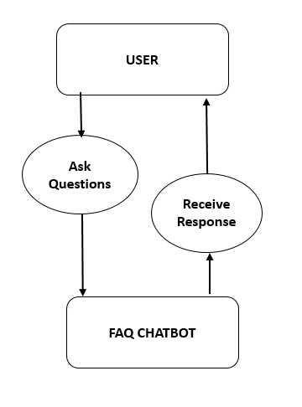

**CHAPTER 2 BACKGROUND AND RELATED WORK**

# 2.1 Problem Statement:

Make a chatbot available 24/7 for stakeholders and customers which can answer all their queries regarding the rules, acts, and circulars of the Mining Industry.

**2.2 Background and Related Work:**

**2.2.1 Background Work:**

**2.2.2 Literature survey:**

**2.3 Solution Approach (methodology and technology used)**

**1. Programming Languages:** Python, Javascript, HTML are the programming languages used to build chatbot.

**2. Cloud Certifications:** Certifications from Amazon Web Services, Microsoft’s Azure, and Google Cloud Platform can be beneficial as these platforms offer various chatbot services.

**3. Software as a Service (SaaS) Tech Stacks:** There are several chatbot messaging platforms that don’t require starting from scratch with code.

**4. Natural Language Processing (NLP) and Machine Learning:** These are the main technologies behind chatbots. When a question is presented to a chatbot, complex algorithms process the received input, understand what the user is asking, and determine the answer suitable to the question.

**5. Natural Language Understanding (NLU):** This technology accurately interprets user questions and matches them to specific intents.

**6. Solution Flow Management:** This involves managing the flow of the conversation and providing appropriate responses based on the user's input.

**7. Natural Language Generation:** This involves generating human-like responses to user queries.

# CHAPTER 3

# DESIGN (UML AND DATA MODELING)

# 

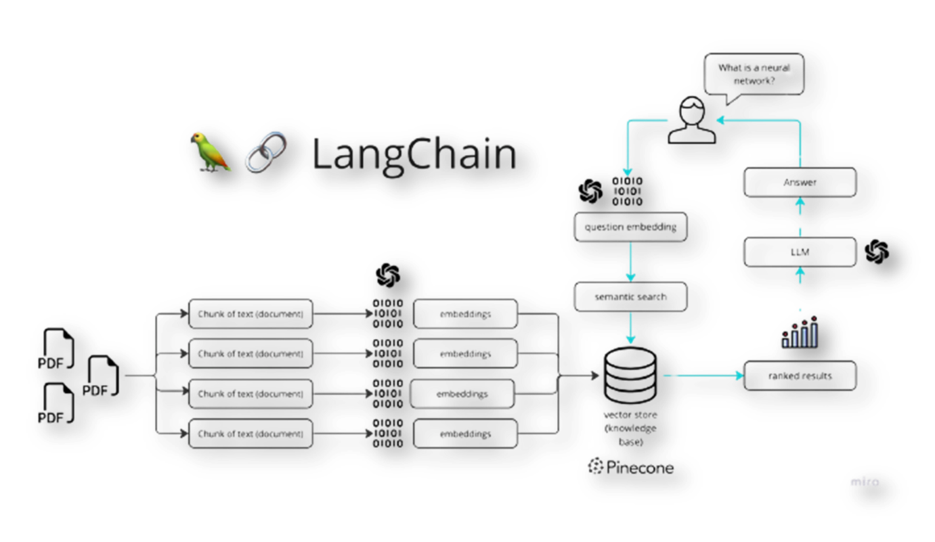

# CHAPTER 4 IMPLEMENTATION

**4.1 Tools and Technology:**

**Python Libraries used :**

* langchain==0.0.184
* PyPDF2==3.0.1
* python-dotenv==1.0.0
* streamlit==1.18.1
* openai==0.27.6
* faiss-cpu==1.7.4
* altair==4
* tiktoken==0.4.0

**Data Collection and Scraping Tools:**

* APIs provided by OpenAi

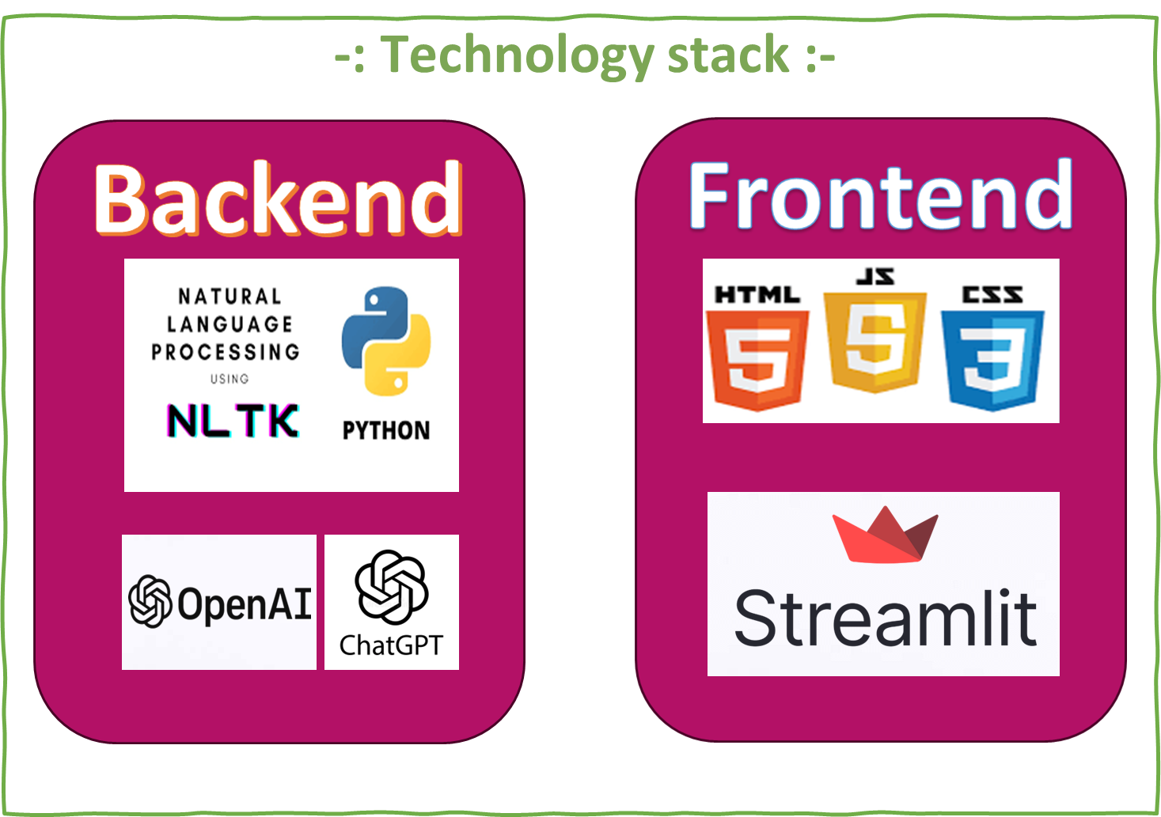

**4.3 User Manual:**

**Step 1 :** Run Command Prompt as Administrator.

**Step 2 :** Locate and activate python interpreter. For Example :-

cd C:\_____________\Minor_project\Scripts\activate

**Step 3 :** Go to the directory C:\_____________\Minor_project

**Step 4 :** Run the following command : streamlit run app.py

**Step 5 :** Load your Mining Industry rules and regulations PDFs and click Process.

**Step 6 :** After completing the process, ask your question to Mining Industry Chatbot.

# CHAPTER 5

# PROJECT PLAN

**5.2. Effort Schedule & Cost estimation:**

**Effort Schedule:-**

**Project Initiation:**

Define project objectives: 1 day

Gather project requirements: 2 days

Develop project plan: 1 day

Total duration: 4 days

**Project Data Collection:**

Collect Mining Industry Rules & Regulations data: 1 day

Total duration: 1 day

**Project Development:**

User Interface : 3 days

Total duration: 3 days

**Project Report and Presentation:**

Generate project report: 1 day

Prepare project presentation: 1 day

Total duration: 2 days

**Project Review and Closure:**

Review project outcomes: 1 days

Project documentation: 2 day

Total duration: 3 days

Total Project Duration: Approximately 13 days

Please note that these are rough estimates, and the actual effort required may vary based on the complexity of your project.

**Cost Estimation:-**

There is no need of any type of expenses in our project. All the resources are open source and free to use.

# CHAPTER 6

# PROJECT SCREENSHOT

# 

# 

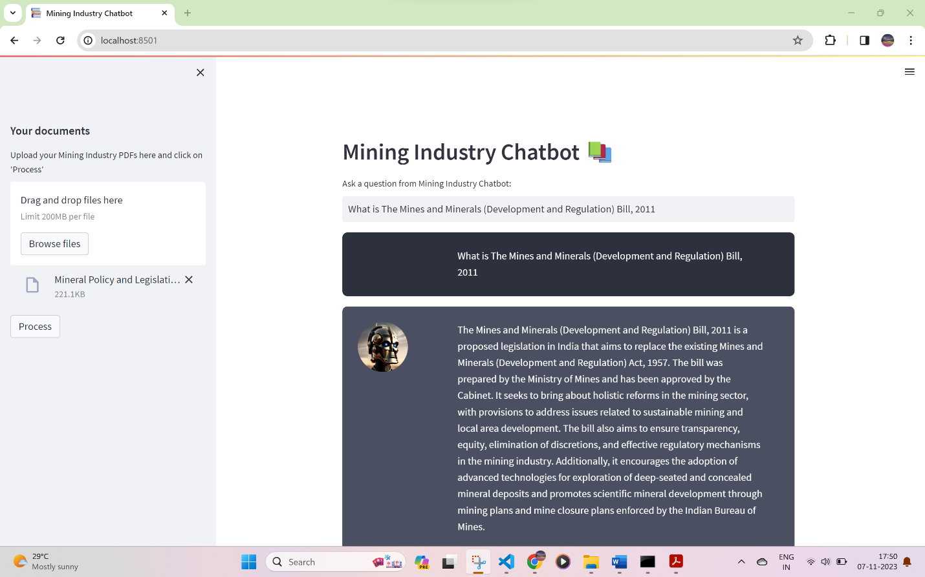

# CHAPTER 7

# CONCLUSION & FUTURE SCOPE

**7.1 Conclusion:-**

In conclusion, the chatbot project has demonstrated the potential of artificial intelligence in enhancing customer service and business operations. The project has successfully developed a chatbot that can understand and respond to user queries in a timely and accurate manner. The use of technologies such as Natural Language Processing (NLP) and Machine Learning (ML) has enabled the chatbot to provide a more personalized and efficient service.

The project has also highlighted the importance of continuous improvement and adaptation in the field of AI. As user needs and business requirements evolve, so too must the chatbot. This involves regular updates and modifications to the chatbot’s algorithms and functionalities.

Furthermore, the project has underscored the significance of security and data protection in AI applications. Ensuring that user data is handled responsibly and securely is paramount.

**7.2 Future Scope:-**

There is a future scope of using this chatbot on other platforms like Mobile Phones, Smart Watches etc.

Overall, the chatbot project has not only achieved its objectives but also paved the way for future innovations in the field of AI and chatbots. The lessons learned from this project will undoubtedly contribute to the development of more advanced and effective chatbots in the future. The future of chatbots looks promising, with advancements in AI and ML leading to more sophisticated and helpful chatbots. As businesses continue to recognize the benefits of chatbots, their adoption is likely to increase, making them an integral part of customer service and business operations.

**Bibliography**

[chatbotsmagazine.com](https://chatbotsmagazine.com/how-to-document-chatbot-requirements-7df81275cc66)

[**https://medium.com/analysts-corner/the-amazing-chatgpt-functional-and-non-functional-requirements-da9bb91bb406**](https://medium.com/analysts-corner/the-amazing-chatgpt-functional-and-non-functional-requirements-da9bb91bb406)**.**

<https://python.langchain.com/docs/get_started/introduction>

<https://docs.streamlit.io/>